Database Connection Using Node.js

Step 1) open xampp server and start Apache and MySql

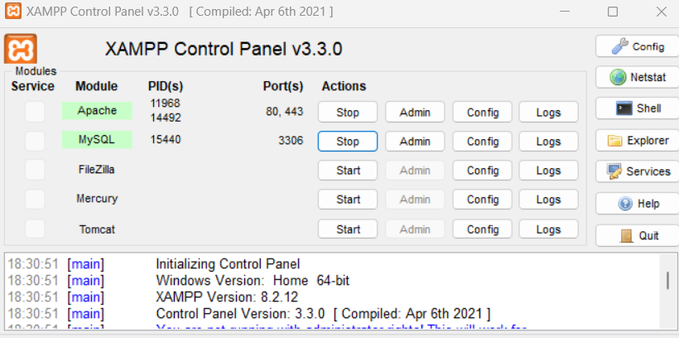

Step 2) open browser and type <http://localhost/phpmyadmin/>

**click on Databases**

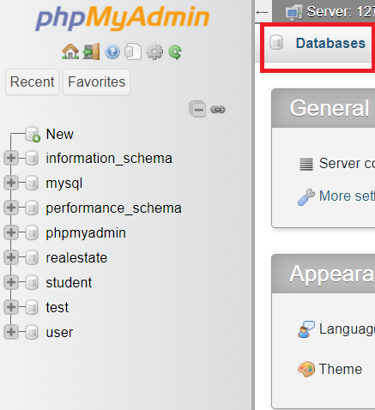

Enter Column name and data Type and set Primary key

Structure of table

Step 3) Install Mysql using Node Js

Type :- npm I mysql in terminal

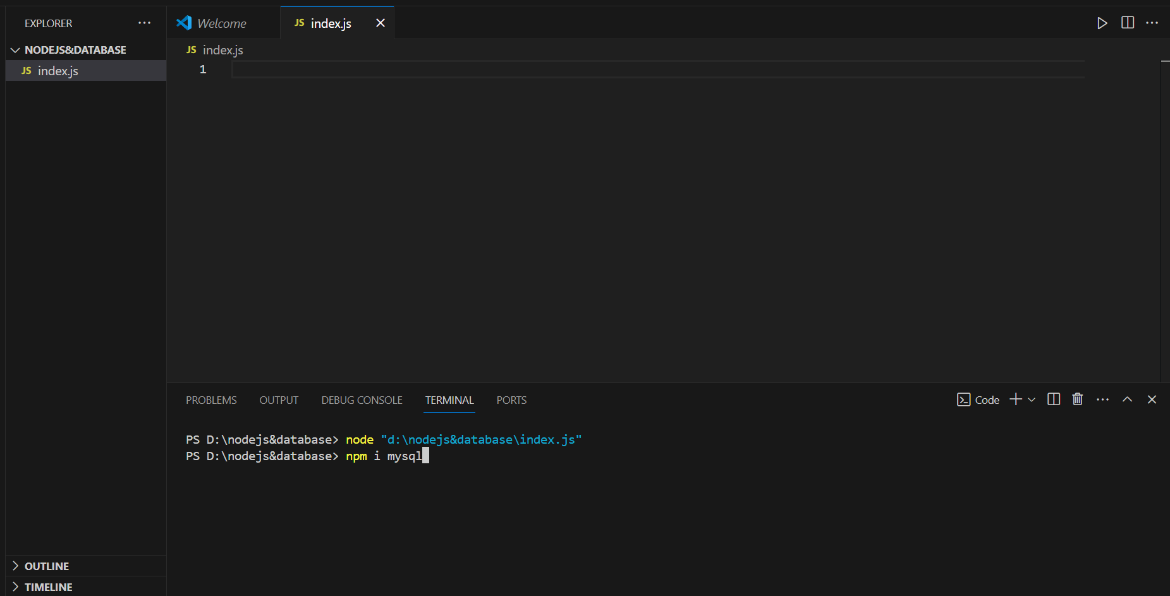

Now check package.json file that Mysql is installed 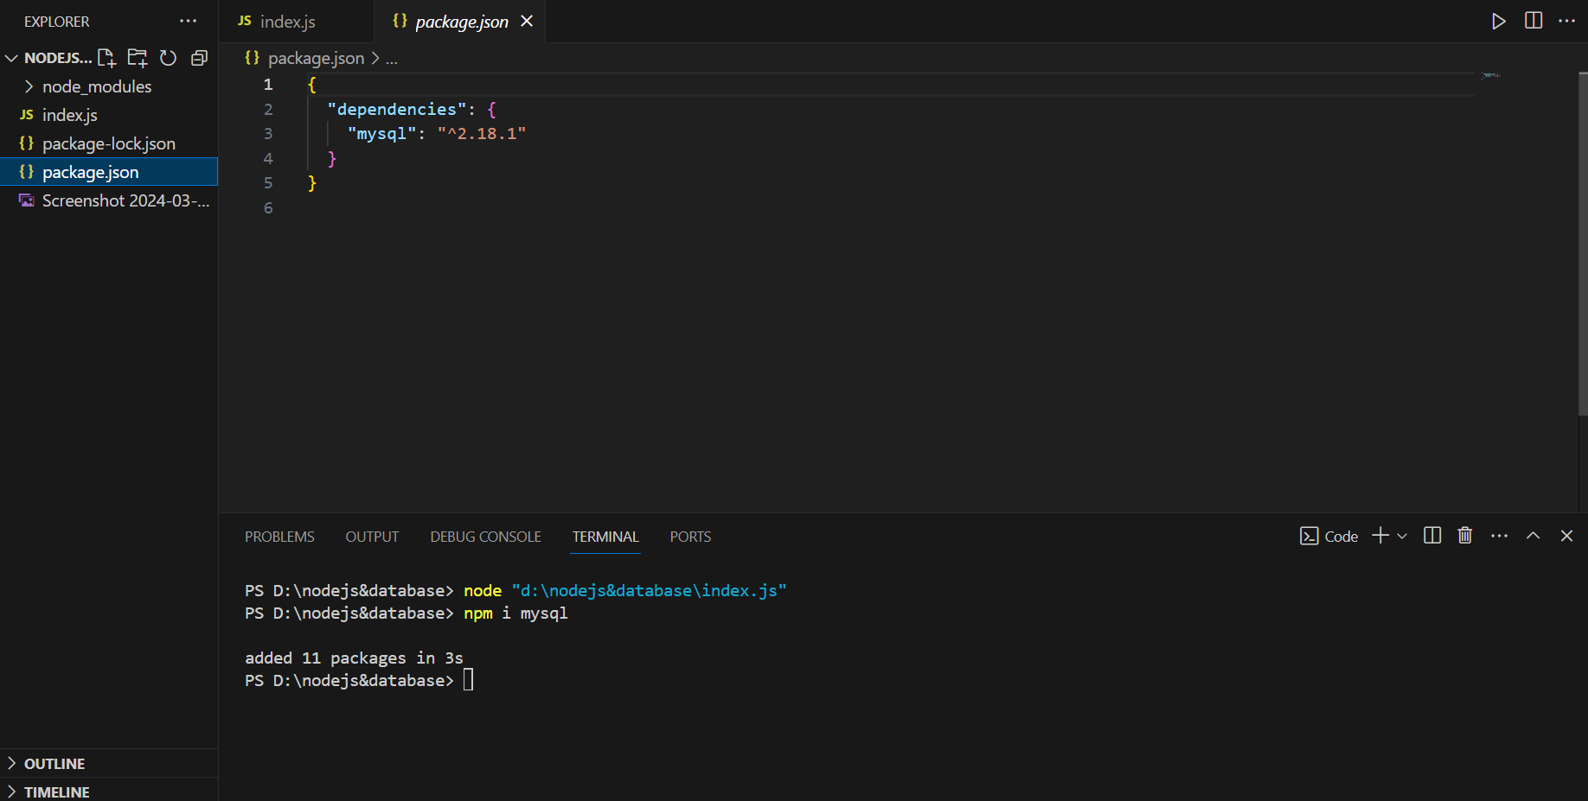

Step 4) write connection code now type node index.js in terminal

var mysql = require('mysql');

var con = mysql.createConnection({

  host: "localhost",

  user: "root",

  password: "",

  database:"project"

});

con.connect(function(err) {

  if (err) throw err;

  console.log("Connected!");

});

